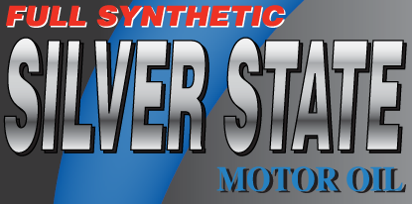

Silver State Full Synthetic Automatic Transmission Fluid
For California Only

Silver State Full Synthetic Automatic Transmission Fluid is a full synthetic ATF that is designed for use in automatic transmissions in most domestic and import passenger cars and light trucks. Silver State Full Synthetic ATF provides superior thermal stability and anti-wear protection. Its frictional properties provide smooth shifting and excellent anti-shudder performance in a wide range of vehicles.

BENEFITS:
- Guarantees peak transmission performance during high temperature operation
- Excellent anti-wear protection; increases transmission life
- Outstanding oxidative stability, foam resistance and corrosion control
- Excellent shear stability to ensure a long service life
- Maximum protection for towing and severe service
- Improved shift quality

Silver State Full Synthetic ATF is a full synthetic ATF designed for most conventional planetary gear transmission applications and meets JASO M315-2013, Class 1A-LV requirements. This product is NOT recommended for Ford Type F, Continuously Variable Transmissions (CVT) or Duel Clutch Transmissions (DCT) which require specialized Original Equipment Manufacturer (OEM) licensed products.
Silver State Full Synthetic ATF has undergone extensive testing for a broad range of transmissions but is not an OEM licensed product. The respective vehicle manufacturers have not endorsed or evaluated Silver State Full Synthetic ATF in these applications. If an OEM Licensed product is preferred, contact your local distributor for information on obtaining an OEM licensed product.

A SUPERIOR PRODUCT BY COLORADO PETROLEUM 5-6-2019 JDS

